Team Members: Miramichi 2011
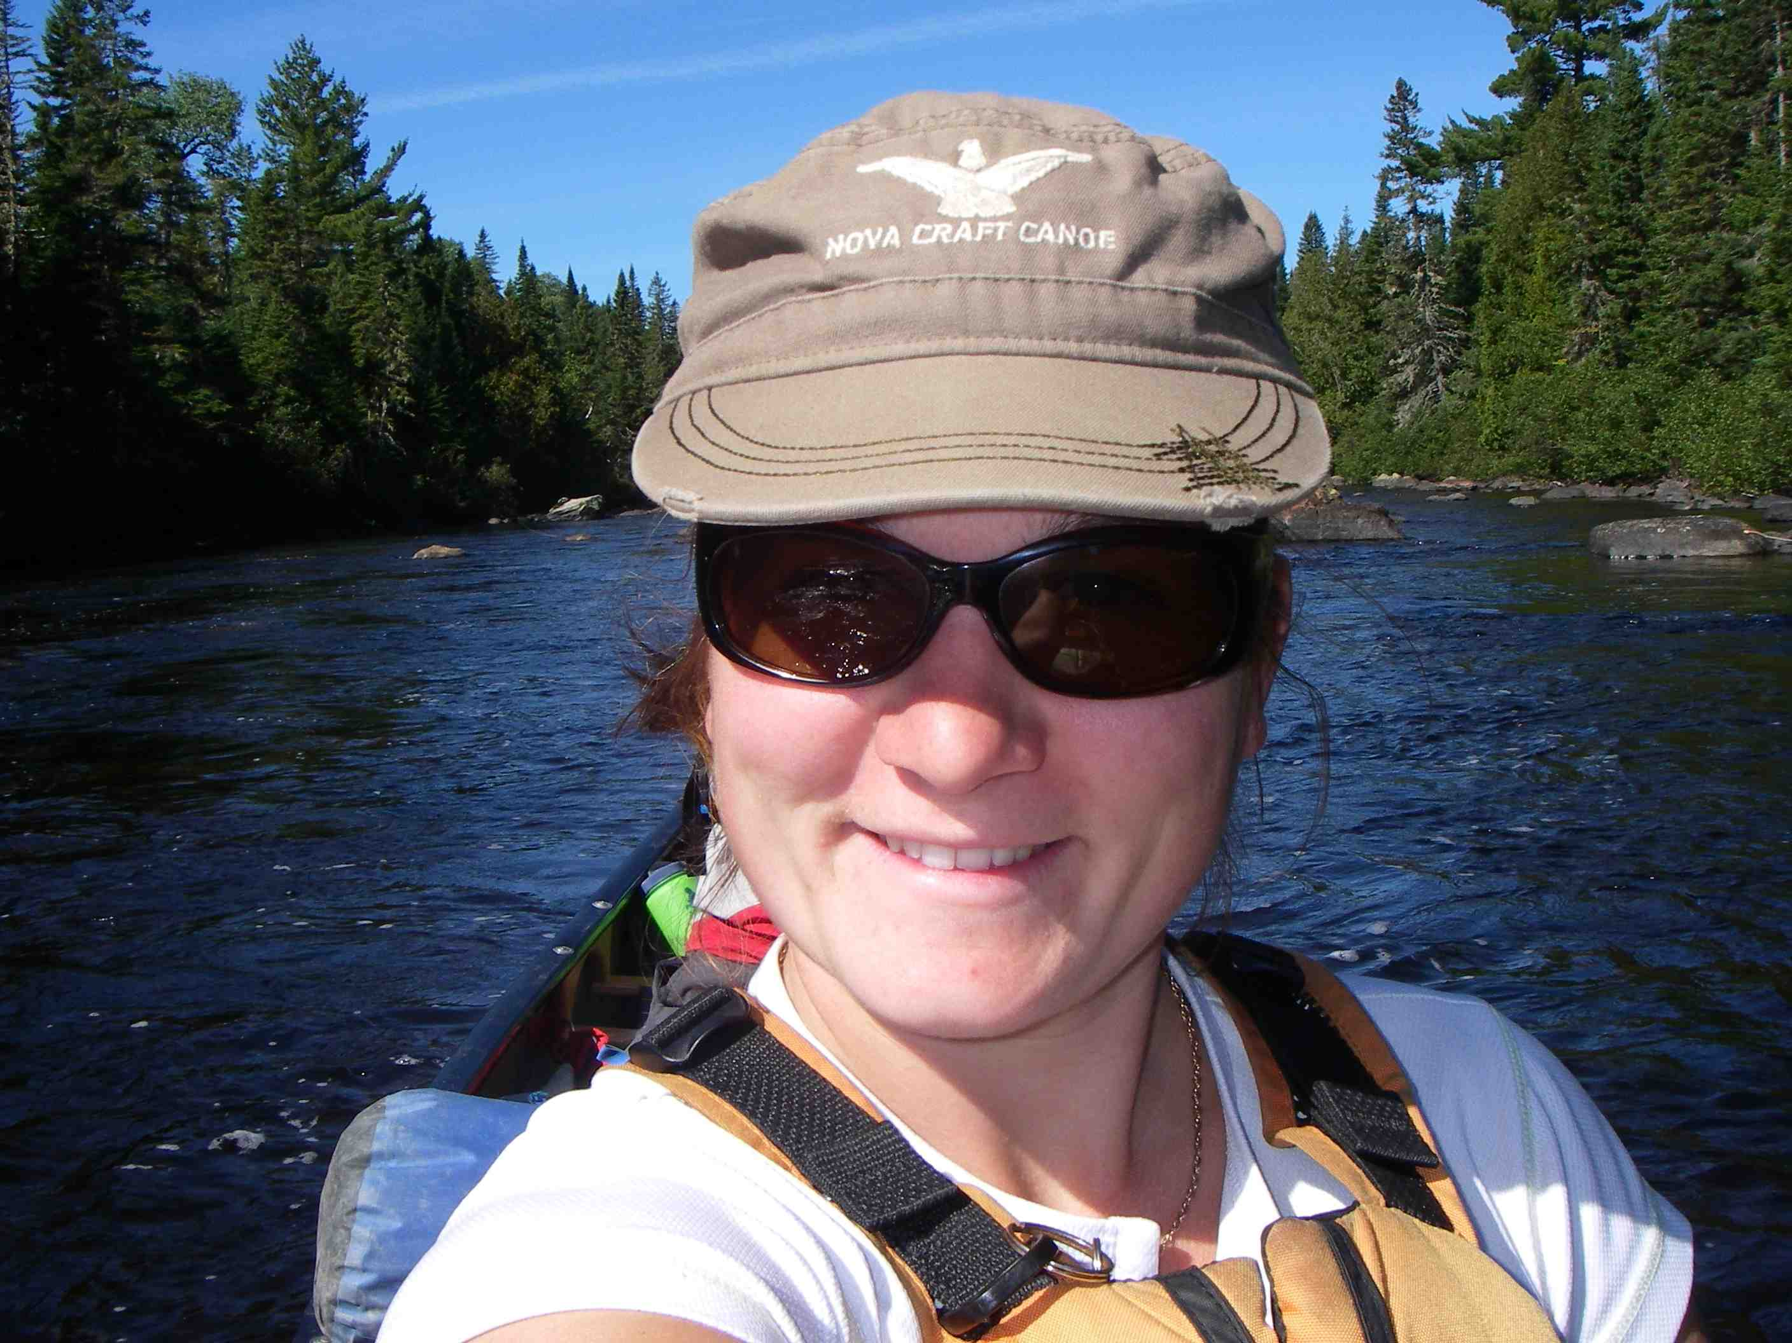
Geneviève Labonté (Canadian Canoe Foundation Representative and Guide-Arpin Canoe Restigouche,)
Genevieve was born in Breakeyville, a village on the south shore of Quebec. After her course in Adventure Tourism, she gained experience as a guide in a sea kayak company in the summer and a dog sledding company in the winter. In 2007 she became co-owner of ''Nature-Aventure'' a company located in Matapédia in the Gaspé, where she manages and guides canoe, kayak and hiking adventures. She holds the following certifications: level 3 whitewater and lake water canoeing, whitewater rescue and wilderness first aid. She loves working with youth, teaching them canoeing and camping skills. Genevieve worked with the Canadian Canoe Foundation on the Restigouche River Project in September 2010.
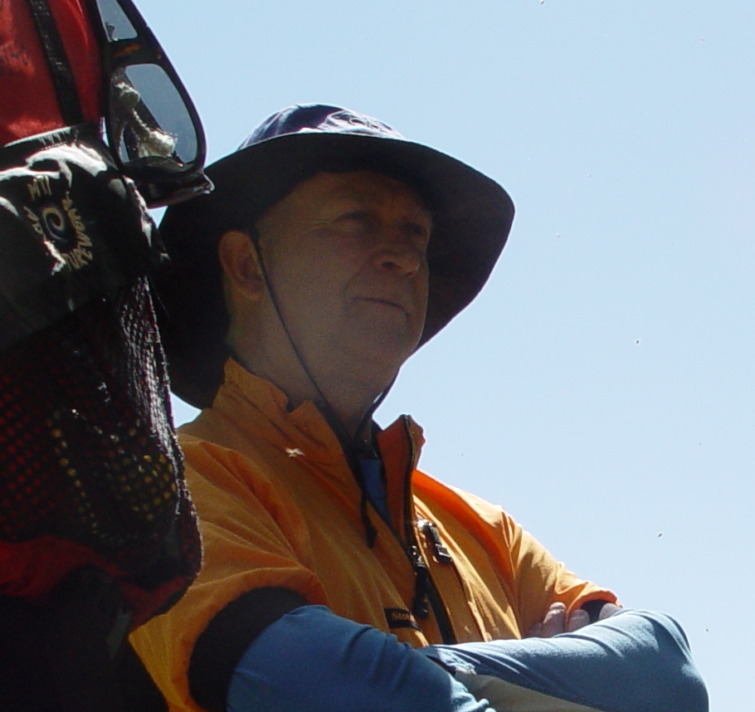
André Roy (Guide- Arpin Canoe Restigouche)
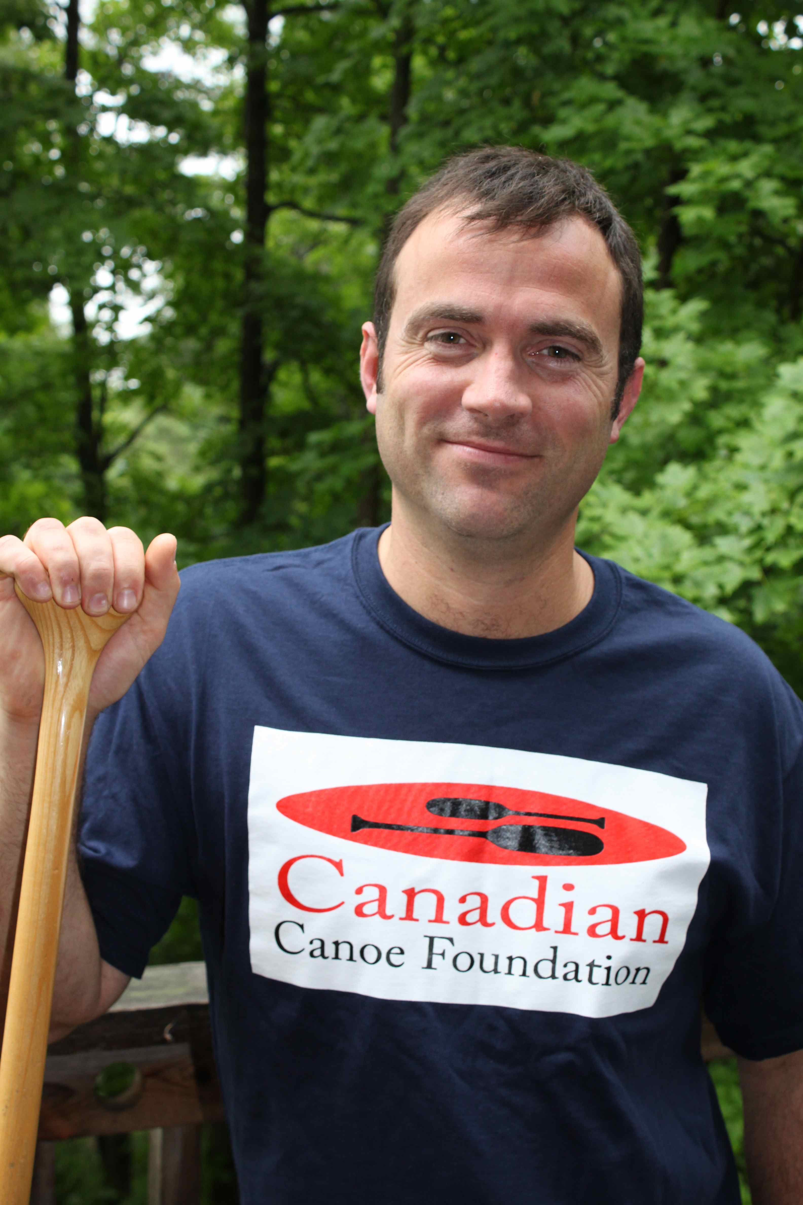
Andre is originally from Bathurst New Brunswick. He worked as a teacher for 32 years (grades 7 and 8). An avid outdoors person, he has been canoeing for 37 years. 2 years ago he went on a 28 day adventure on the Nahanni River. He has Senior Instructor certification in canoe camping, flatwater canoeing and whitewater canoeing. André has guided groups from different regions across Canada and Europe as a guide for Arpin Canoe Restigouche and other organizations.
Patrick Henry (President and Founder, Canadian Canoe Foundation)

Patrick lives in Chelsea, Québec. He is the Founder of the Canadian Canoe Foundation, a registered charity that sends youth on canoe-trip environmental education adventures. He holds his teachers certification in Ontario and an Environmental Studies degree from Trent University. Besides his work with the Foundation, he works as an environmental consultant with organizations including NatureServe Canada and Environment. Patrick’s first love is canoeing; he has guided wilderness canoe trips across Canada including 40 day expeditions in Canada’s Arctic. He has published articles on these adventures and works as a public speaker describing these experiences and his objective of developing the next generation of environmental leaders.

